DBMS
Q3 CREATE TABLE
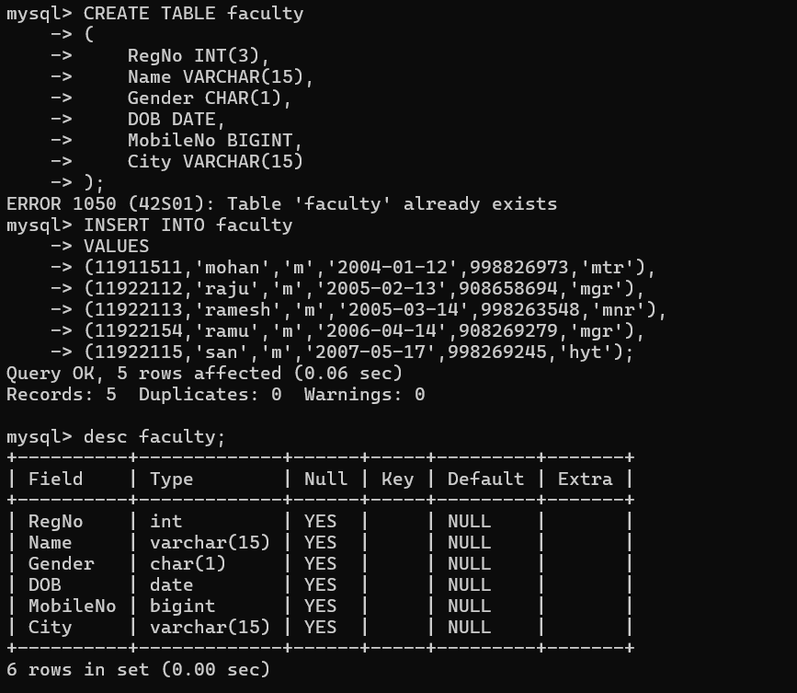

DESC FACULTY
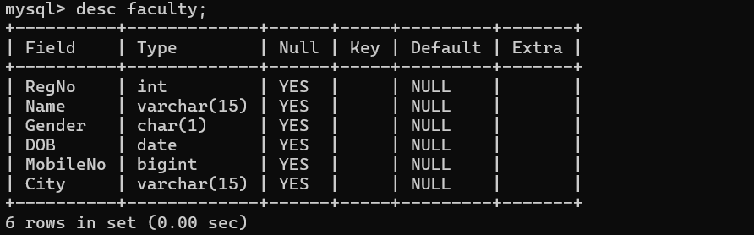

SELECT* FROM FACULTY
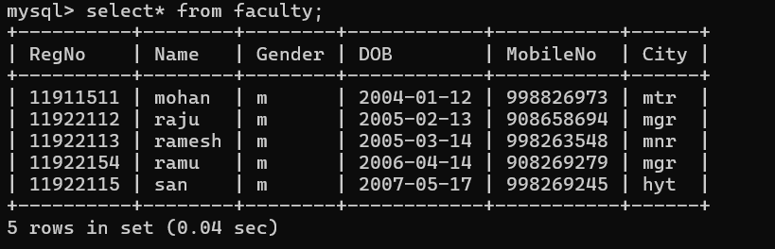
INSERT
